Panji Iman Baskoro

171111023 / TI

Praktikum Pemprograman Dasar 2

LinkedListNode.java

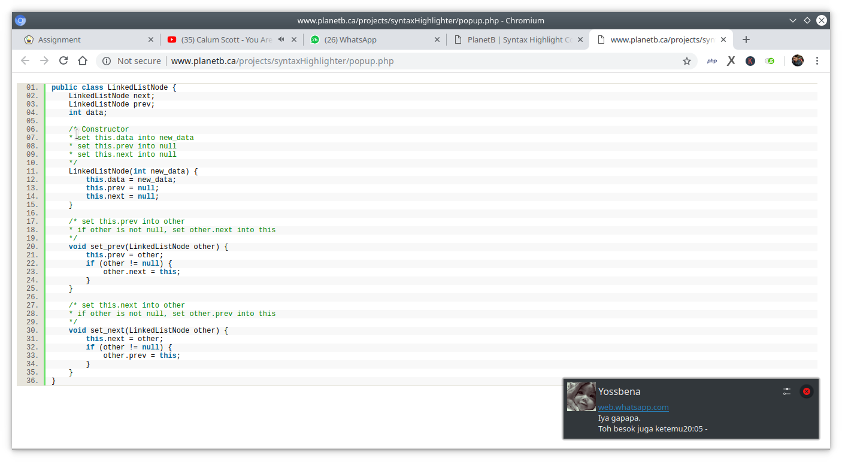

LinkedList.java (quick sort)

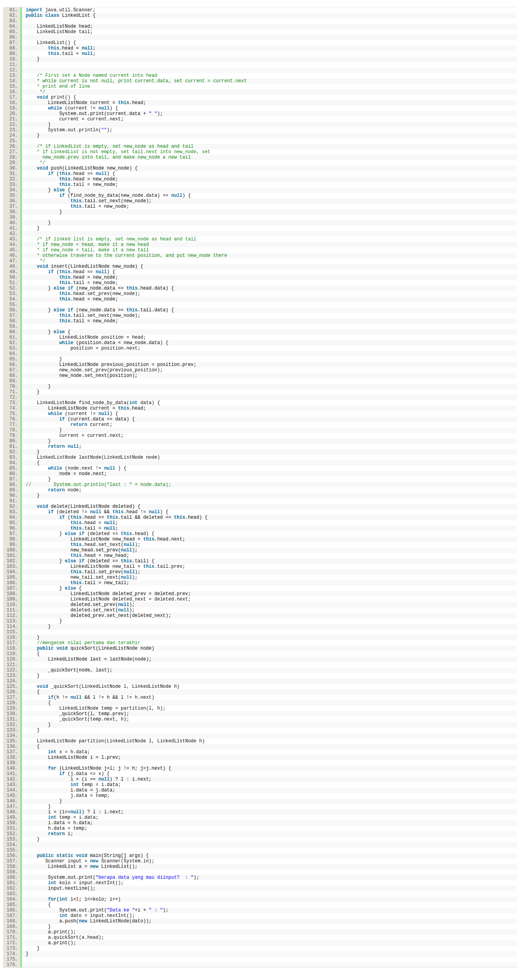

 LinkedList.java (Quick sort)



LinkedList.java (Quick Sort)

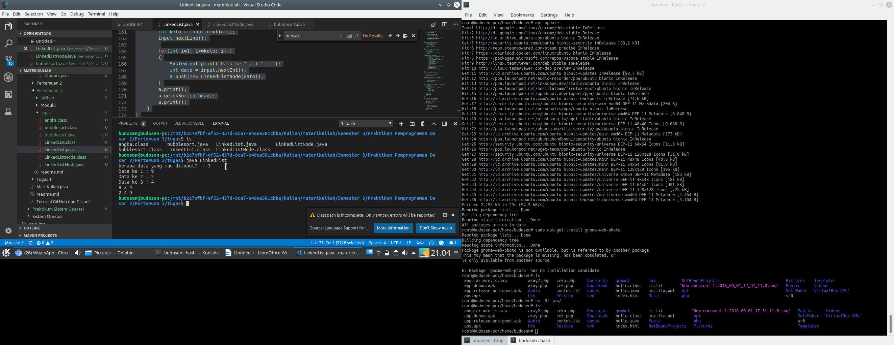 LinkedList.java output

bublesort.java

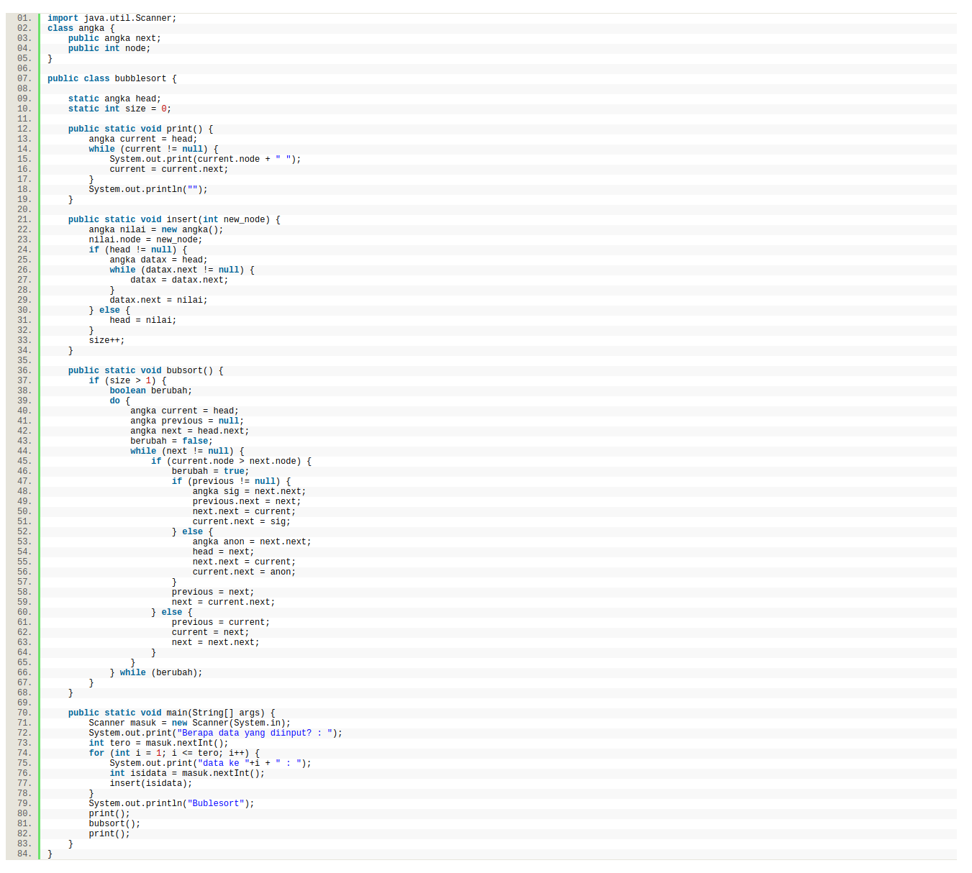

 bublesort.java

bublesort.java output

